**Part 1: Azure Infrastructure Configuration**

**Task 1.1: Create Resource Groups based on different project environments (e.g. Development, Testing, Production). Explain the organizational benefits of using Resource Groups.**

**Development:**

**Testing:**

**Production:**

Resource Groups play a crucial role in organizing and managing resources within an organization. Let’s divide into their benefits and how they enhance the overall efficiency and effectiveness of project environments,

1. **Centralized Management:** Resource groups provide a centralized way to organize and manage resources within an organization. Instead of scattering resources across different platforms or services, they can be grouped logically based on projects, departments, or environments. This centralized approach simplifies resource management tasks such as provisioning, monitoring, and access control.
2. **Cost Management:** Resource groups help in effectively managing costs by providing visibility into resource usage and spending. By grouping resources based on projects or departments, organizations can track and allocate costs more accurately. This enables better budget planning and optimization of resource utilization, ultimately leading to cost savings.
3. **Security and Compliance:** Organizing resources into groups allows for more granular control over security policies and access controls. Administrators can define permissions and policies at the resource group level, ensuring consistent security measures across all resources within the group. This helps in enforcing compliance with regulatory requirements and mitigating security risks.
4. **Scalability and Performance:** Resource groups enable organizations to scale resources up or down more efficiently based on demand. By grouping related resources together, it becomes easier to provision additional capacity or optimize performance for specific workloads. This scalability ensures that resources are available when needed, minimizing downtime and improving overall performance.
5. **Streamlined Operations:** Resource groups facilitate streamlined operations by providing a clear organizational structure for managing resources. Teams can collaborate more effectively within the context of resource groups, making it easier to coordinate tasks, share information, and troubleshoot issues. This streamlining of operations improves productivity and enhances the overall efficiency of the organization.
6. **Automation and DevOps Practices:** Resource groups support automation and DevOps practices by providing a consistent environment for deploying and managing infrastructure and applications. Automation scripts and deployment pipelines can target specific resource groups, allowing for standardized and repeatable deployment processes. This automation accelerates the delivery of new services and features while reducing the risk of errors and inconsistencies.

**Task 1.2: Explore and document the purpose and usage of Availability Zones and Availability Sets in ensuring application reliability, without creating VMs.**

The purpose and usage of **Availability Zones** and **Availability Sets** in ensuring application reliability within Azure:

**1.Availability Sets**:

* + **Purpose**:
    - An **Availability Set** is a logical grouping of virtual machines (VMs) within an Azure region.
    - It ensures that VMs are distributed across different **fault domains** and **update domains**.
  + **Usage**:
    - **Fault Domains**:
      * Fault domains represent distinct physical hardware within a datacentre.
      * VMs in the same fault domain share common storage, power sources, and network switches.
      * If one fault domain experiences an issue (e.g., hardware failure), VMs in other fault domains remain unaffected.
    - **Update Domains**:
      * Update domains group VMs that can be rebooted simultaneously during planned maintenance.
      * VMs in different update domains ensure that not all VMs are updated or rebooted at the same time.
    - **Benefits**:
      * **Improved Availability**: By spreading VMs across fault domains and update domains, you reduce the risk of simultaneous failures.
      * **Downtime Reduction**: Using an availability set decreases acceptable downtime to around **22 minutes per month** compared to a single VM deployment.
      * **VM Isolation**: VMs within an availability set remain isolated from each other.
      * **Resource Management**: Availability sets apply only to VMs and cannot be used for other Azure resources.
      * **Redundancy Planning**: Architect your application to fail over to non-impacted VMs for redundancy and business continuity.

**2. Availability Zones**:

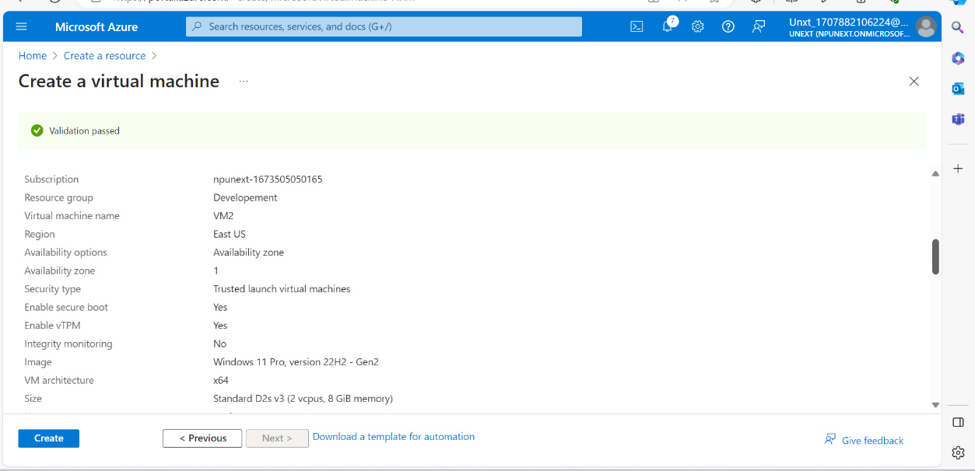

* + **Purpose**:
    - **Availability Zones** take reliability to the next level by providing high availability across different datacenters within an Azure region.
    - Each zone consists of one or more datacenters.
  + **Usage**:
    - **Zone-Aware Services**:
      * When you use availability zones, your workload is spread across different zones within an Azure region.
      * An Azure region comprises multiple datacenters, and each zone is composed of one or more datacenters.
    - **Benefits**:
      * **99.99% SLA**: With availability zones, your acceptable downtime per month reduces to less than **5 minutes**.
      * **Zone Resilience**: VMs are distributed across different zones, ensuring resilience even if an entire zone experiences issues.
      * **Proximity**: VMs in an availability set have improved VM-to-VM latencies compared to availability zones.
      * **High Availability**: Availability zones minimize single points of failure and offer high availability.

In summary, **Availability Sets** provide a structured way to organize VMs within a single location, while **Availability Zones** extend reliability by spanning multiple datacenters. Architects can choose the appropriate level of redundancy based on their application requirements and desired SLAs.